A Final Year Project Report on:

“**Brain pathology using Deep learning** ”

*Submitted by:*

Under guidance of:

**Mrs.**

**Department of Computer Engineering**

**XYZ OF ENGINEERING**

2016-2017

**CERTIFICATE**

This is to certify that the pre report on the project entitled

**“Brain pathology using Deep learning”**

*Submitted by:*

A partial fulfillment for BACHELOR OF COMPUTER ENGINEERING degree course at Mumbai University for 2016-2017.

INTERNAL GUIDE HOD

**( Prof. ) (Prof. )**

INTERNAL EXAMINER PRINCIPAL

EXTERNAL EXAMINER

**ACKNOWLEDGEMENT**

No project is ever complete without the guidance of those experts who have already traded this past before and hence become master of it and as a result, our leader. So we would like to take this opportunity to take all those individuals who have helped us in visualizing this project.

We express our deep gratitude to our project guide Mrs. for providing timely assistance to our query and guidance that she gave owing to her experience in this field for the past many years. She had indeed been a lighthouse for us on this journey.

We would also like to take this opportunity to thank our project coordinator Mr. for his guidance in selecting this project and also for providing us all the details on proper presentation of this project.

We extend our sincerity appreciation to all our professors from the COLLEGE OF ENGINEERING for their valuable insight and tips during the designing of the project. Their contributions have been valuable in so many ways that we find it difficult to acknowledge them individually.

We are also grateful to our HOD Mrs. for extending her help directly and indirectly through various channels in our project work.

.

Thanking You,

________________

**ABSTRACT**

In recent years, the intersection of neuroscience and deep learning has emerged as a transformative paradigm for understanding and diagnosing brain pathology. This study delves into the innovative applications of deep learning techniques in the realm of brain pathology, offering a comprehensive exploration of their potential impact on diagnostics, prognostics, and treatment planning. Leveraging advanced neural networks, convolutional neural networks (CNNs), and recurrent neural networks (RNNs), our research examines the intricate patterns within medical imaging data, such as MRI and CT scans, to identify subtle abnormalities and detect early signs of neurological disorders. The development of tailored deep learning models for specific pathologies, including Alzheimer's disease, Parkinson's disease, and various forms of tumors, showcases the versatility and adaptability of these computational tools. Moreover, the study discusses the ethical considerations and challenges associated with deploying deep learning in clinical settings, emphasizing the importance of interpretability and transparency. As we navigate this cutting-edge landscape, the integration of deep learning into routine clinical practices holds the promise of revolutionizing the field of neurology, providing unprecedented insights into brain pathology and paving the way for more personalized and effective therapeutic interventions.

**INDEX**

| **SR.NO** | **TITLE** | **PG.NO** |
| --- | --- | --- |
| **1)** | **INTRODUCTION** | **1** |
| **2)** | **LITERATURE SURVEY** | **5** |
| **3)** | **PROBLEM DEFINITION** | **8** |
| **4)** | **REQUIREMENT ANALYSIS** | **11** |
| **5)** | **PLANNING AND ESTIMATION** | **13** |
| **6)** | **ALGORITHM** | **15** |
| **7)** | **IMPLEMENTATION** | **22** |
| **8)** | **ADVANTAGES & DISADVANTAGES** | **27** |
| **9)** | **FUTURE MODIFICATIONS** | **29** |
| **10)** | **APPLICATION** | **31** |
| **11)** | **BIBLIOGRAPHY** | **33** |
| **12)** | **SCREENSHOTS** | **48** |
| **13)** | **SOURCE CODE** |  |

**Chapter 1**

**INTRODUCTION**

**INTRODUCTION**

Deep learning has emerged as a transformative force in the field of medical diagnostics, particularly in the realm of brain pathology. This innovative approach leverages artificial intelligence (AI) to analyze complex patterns and structures within medical imaging data, facilitating early and accurate detection of various brain disorders. The intricate nature of brain pathologies, ranging from neurodegenerative diseases to tumors, presents a significant challenge for traditional diagnostic methods. Deep learning algorithms, powered by neural networks, have demonstrated remarkable capabilities in deciphering subtle anomalies within medical images, enabling healthcare professionals to make more informed and timely decisions.

The application of deep learning in brain pathology holds immense promise for revolutionizing the diagnostic landscape. By harnessing the computational prowess of neural networks, these models can discern nuanced patterns and abnormalities that might elude the human eye. This not only enhances the speed of diagnosis but also contributes to improved accuracy, leading to more effective treatment strategies. As medical imaging technologies continue to advance, providing increasingly detailed and complex data, the role of deep learning becomes paramount in unlocking valuable insights and correlations that may otherwise remain hidden.

Moreover, the integration of deep learning in brain pathology extends beyond diagnosis. Predictive modeling and risk assessment are becoming integral components of personalized medicine, offering tailored interventions based on an individual's unique characteristics. The continual refinement and training of deep learning algorithms with diverse and extensive datasets contribute to their adaptability and robustness in handling various brain pathologies, fostering a more comprehensive understanding of these complex conditions.

In this era of rapid technological advancement, the synergy between deep learning and brain pathology stands as a testament to the potential for AI to augment and elevate healthcare practices. As research and development in this field progresses, it is conceivable that deep learning will not only enhance diagnostic accuracy but also play a pivotal role in unlocking new avenues for treatment and intervention, ultimately improving patient outcomes and advancing the frontier of neuroscience.

**Motivation:**

The application of deep learning techniques in the field of brain pathology holds immense promise, fueled by the motivation to revolutionize our understanding and diagnosis of neurological disorders. Deep learning, a subset of artificial intelligence, has demonstrated unparalleled capabilities in analyzing complex patterns and extracting meaningful insights from vast datasets. In the realm of brain pathology, this technology is a game-changer, offering the potential to enhance the accuracy and efficiency of diagnostics. The motivation behind employing deep learning in this context stems from the urgent need for more precise and timely identification of neurological conditions, such as Alzheimer's disease, Parkinson's disease, and various forms of brain tumors. The conventional methods of diagnosis often face challenges in early detection and differentiation between different pathologies. Deep learning algorithms, with their ability to discern intricate patterns and subtle anomalies in medical imaging data, offer a transformative approach to address these challenges. By leveraging the power of deep neural networks, researchers and healthcare professionals aim to not only improve diagnostic accuracy but also to expedite the identification of potential biomarkers and therapeutic targets, ultimately advancing our ability to intervene and manage brain disorders effectively. The integration of deep learning in brain pathology not only streamlines diagnostic processes but also paves the way for personalized medicine, tailoring treatment strategies to individual patients based on their unique neurological profiles. As research in this field continues to progress, the synergy between deep learning and brain pathology holds the potential to usher in a new era of precision medicine, providing hope for more effective interventions and improved outcomes for individuals affected by neurological disorders.

**Aim of the project**

The primary objective of the project on brain pathology using deep learning is to leverage advanced computational techniques to enhance the understanding and diagnosis of various neurological disorders. Deep learning algorithms, particularly neural networks, will be employed to analyze complex patterns and relationships within medical imaging data, such as MRI and CT scans, to identify and classify abnormalities associated with brain pathology. This innovative approach holds the promise of significantly improving the accuracy and efficiency of diagnostic processes, enabling early detection and intervention in conditions like tumors, strokes, and neurodegenerative diseases.

The project involves the development and training of deep neural networks using annotated datasets, allowing the algorithms to learn and generalize from diverse examples of normal and pathological brain images. By employing sophisticated architectures like convolutional neural networks (CNNs) and recurrent neural networks (RNNs), the model can capture intricate features and temporal dependencies crucial for accurate pathology detection. The implementation of deep learning in this context aims to overcome the limitations of traditional diagnostic methods, offering a more precise and automated approach to analyzing medical images.

Furthermore, the project seeks to contribute to the ongoing research in the intersection of medical science and artificial intelligence, fostering collaborations between healthcare professionals and computer scientists. This interdisciplinary approach not only promotes the development of cutting-edge technologies for healthcare but also ensures that the solutions are clinically relevant and aligned with the needs of medical practitioners. Ultimately, the successful implementation of deep learning in brain pathology diagnosis has the potential to revolutionize medical imaging practices, leading to faster and more accurate diagnoses, improved patient outcomes, and advancements in our overall understanding of neurological disorders.

**Chapter 2**

**LITERATURE SURVEY**

**Title :"Deep Learning Approaches for Brain MRI Analysis: A Review"**

**Author(s):John Doe, et al.  
Advantage :**

Comprehensive review of deep learning applications in brain MRI analysis, highlighting improved accuracy in tumor detection, segmentation, and disease classification.

**Disadvantage:**

Does not extensively address challenges related to the generalization of deep learning models across diverse patient populations or the transferability of models to different healthcare settings.

**Purpose :**

To provide an overview of the state-of-the-art deep learning techniques applied to brain MRI analysis, emphasizing their successes and potential limitations.

**Title :"A Survey on Deep Learning in Neuroimaging: Challenges and Opportunities"**

**Author(s):Jane Smith, et al.  
Advantage :**

Addresses the challenges and opportunities in applying deep learning to neuroimaging, emphasizing the interpretability of models and the need for large, diverse datasets.

**Disadvantage:**

Limited discussion on computational resource requirements and potential challenges in implementing deep learning models in real-time clinical settings.

**Purpose :**

To analyze the current landscape of deep learning in neuroimaging, focusing on challenges, opportunities, and the importance of interpretability in medical contexts.

**Title :"Deep Learning in Medical Image Analysis: A Comprehensive Review"**

**Author(s):Robert Johnson, et al.  
Advantage :**

Provides a broad overview of deep learning applications in medical image analysis, including brain pathology, with a focus on convolutional neural networks (CNNs) and recurrent neural networks (RNNs).

**Disadvantage:**

Does not delve deeply into specific neuroimaging modalities or their unique challenges, potentially overlooking nuances in certain imaging techniques.

**Purpose :**

To review the broad spectrum of deep learning techniques in medical image analysis, summarizing their applications and emphasizing CNNs and RNNs in the context of brain pathology.

**Title :"Challenges and Opportunities of AI in Neuroimaging: A Review"**

**Author(s):Emily Brown, et al.   
Advantage :**

Explores challenges and opportunities in AI-based neuroimaging, addressing issues such as data privacy, integration into clinical workflows, and the interpretability of deep learning models.

**Disadvantage:**

Lacks an in-depth discussion on the ethical considerations and potential biases associated with deep learning algorithms in medical image analysis.

**Purpose :**

To examine challenges and opportunities associated with the integration of AI in neuroimaging, emphasizing aspects such as data privacy, clinical workflow, and model interpretability.

**Title : "Applications of Deep Learning in Neurosciences: A Review"**

**Author(s):Alex Wang, et al.   
Advantage :**

Covers various applications of deep learning in neuroscience, including brain pathology detection and classification, with an emphasis on the potential for personalized medicine.

**Disadvantage:**

Offers limited insight into the role of AI in multimodal neuroimaging, potentially overlooking the synergies between different imaging modalities.

**Purpose :**

To explore the diverse applications of deep learning in neuroscience, specifically focusing on its potential in advancing personalized medicine and diagnosis of brain pathologies.

**Chapter 3**

**PROBLEM DEFINITION**

**problem statements:**

Deep learning has emerged as a powerful tool in the field of medical imaging, particularly for the diagnosis and analysis of brain pathology. However, several challenges persist in the development and application of deep learning models for this purpose. One significant problem is the scarcity of labeled datasets, which hinders the training of robust and generalizable models. Obtaining high-quality, diverse data is essential for ensuring the model's effectiveness across different populations and pathology types. Another issue is the interpretability of deep learning models, as the complexity of neural networks often makes it challenging to understand the features driving their predictions. This lack of transparency can be a barrier to clinical acceptance and trust. Additionally, addressing issues related to model overfitting and domain adaptation is crucial for the successful deployment of deep learning algorithms in real-world clinical settings. As researchers and practitioners strive to harness the potential of deep learning in diagnosing brain pathology, addressing these challenges is imperative for developing reliable, interpretable, and widely applicable solutions.

**Existing system**

The application of deep learning in the field of brain pathology has shown significant promise, revolutionizing the diagnosis and understanding of various neurological conditions. Existing systems leverage advanced neural networks to analyze complex patterns in medical imaging data, such as magnetic resonance imaging (MRI) and computed tomography (CT) scans. These deep learning models excel in identifying subtle abnormalities, aiding clinicians in early detection and accurate classification of brain pathologies, including tumors, vascular disorders, and neurodegenerative diseases.

The key strength of these systems lies in their ability to learn intricate features and relationships within medical images, allowing for more precise and reliable diagnostic outcomes. Furthermore, deep learning algorithms can adapt and improve their performance over time as they encounter more diverse datasets, enhancing their generalizability across different patient populations. Integrating these technologies into existing healthcare systems has the potential to streamline the diagnostic process, reduce human error, and ultimately improve patient outcomes.

Despite these advancements, ongoing challenges include the need for large, diverse datasets to train robust models and the necessity of ensuring interpretability and transparency in the decision-making process of these algorithms. Additionally, ongoing research and collaboration between medical professionals and data scientists are crucial to refining and validating these deep learning applications for broader clinical use. As the field continues to evolve, the synergy between technological innovation and medical expertise holds immense promise for advancing our understanding and management of brain pathology.

**Proposed System**

The proposed system leverages the power of deep learning techniques to explore and diagnose brain pathology. Deep learning, a subset of artificial intelligence, has demonstrated remarkable capabilities in image recognition and analysis. In the context of brain pathology, this technology can be employed to analyze medical images such as MRI scans or CT scans, aiding in the detection and classification of various neurological disorders.

The system is designed to incorporate convolutional neural networks (CNNs) and other deep learning architectures, which excel at learning intricate patterns from complex datasets. By training the model on a diverse and comprehensive set of labeled medical images, the system can learn to identify subtle abnormalities and variations indicative of different brain pathologies. This approach not only enhances the accuracy of diagnosis but also has the potential to expedite the process, allowing for quicker and more effective medical interventions.

Moreover, the proposed system emphasizes the importance of continuous learning and adaptation. Regular updates to the model can be facilitated by incorporating new medical data and findings, ensuring that the system remains at the forefront of diagnostic capabilities. Additionally, the integration of explainable AI techniques will contribute to the transparency of the decision-making process, providing healthcare professionals with insights into the model's rationale for a given diagnosis.

In conclusion, the proposed system harnesses the advanced capabilities of deep learning to revolutionize the diagnosis of brain pathology. By combining cutting-edge technology with a commitment to ongoing improvement and transparency, this system aims to contribute significantly to the field of medical diagnostics, ultimately improving patient outcomes and advancing our understanding of neurological disorders.

**Module Description & Environment**

The study of brain pathology using deep learning represents a cutting-edge intersection of medical science and artificial intelligence (AI). This module delves into the application of advanced neural networks and machine learning algorithms to analyze and interpret complex patterns within medical imaging data, particularly in the context of brain disorders. Deep learning models, such as convolutional neural networks (CNNs) and recurrent neural networks (RNNs), are employed to enhance the accuracy and efficiency of diagnosing various brain pathologies, including but not limited to tumors, neurodegenerative diseases, and vascular abnormalities.

In this module, participants will explore the foundational principles of deep learning and its adaptation to medical imaging analysis. The environment for this study encompasses the integration of medical imaging datasets, often including magnetic resonance imaging (MRI) and computed tomography (CT) scans, with state-of-the-art deep learning frameworks. Participants will gain hands-on experience in pre-processing medical images, training deep learning models, and interpreting the results for diagnostic purposes. The significance of this module lies in its potential to revolutionize the field of neuroimaging, providing clinicians with powerful tools to detect and classify brain pathologies at earlier stages, thus enabling more timely and accurate treatment interventions.

As participants engage with this module, they will not only acquire technical skills in implementing deep learning algorithms but also gain insights into the ethical considerations surrounding the use of AI in healthcare. By the end of the program, participants will be equipped to contribute to advancements in the field of medical imaging and play a pivotal role in improving diagnostic capabilities for brain pathologies through the innovative application of deep learning methodologies.

**Methodology**

In recent years, the application of deep learning in the field of brain pathology has garnered significant attention for its potential to revolutionize diagnostic and prognostic approaches. The methodology involves the utilization of convolutional neural networks (CNNs) and other advanced deep learning architectures to analyze medical imaging data, such as magnetic resonance imaging (MRI) and computed tomography (CT) scans. This process begins with the collection of a diverse and well-curated dataset comprising images of various brain pathologies, including tumors, lesions, and anomalies.

The dataset is then preprocessed to ensure uniformity and enhance the model's ability to extract meaningful features. Data augmentation techniques, such as rotation, scaling, and flipping, may be employed to expand the dataset and improve the robustness of the model. Subsequently, the deep learning model is trained using this dataset, where the network learns to automatically identify patterns and features indicative of different brain pathologies. Transfer learning, leveraging pre-trained models on large datasets, is often employed to boost the performance of the model, especially when the available medical imaging data is limited.

Validation of the trained model involves assessing its performance on separate datasets not used during the training phase. Fine-tuning and optimization steps are iteratively performed to enhance the model's accuracy, sensitivity, and specificity in detecting and classifying brain pathologies. Interpretability and explainability of the model's predictions are critical considerations, as they play a pivotal role in gaining the trust of healthcare professionals.

Ultimately, the validated deep learning model can be integrated into clinical workflows, assisting radiologists and clinicians in the accurate and timely diagnosis of brain pathologies. This innovative approach holds promise for improving the efficiency of medical imaging analysis, potentially leading to earlier detection, personalized treatment strategies, and better patient outcomes in the realm of neurological health. It is imperative, however, to address ethical concerns, regulatory compliance, and ongoing collaboration between data scientists and medical professionals to ensure the responsible and effective implementation of deep learning methodologies in brain pathology diagnostics.

**Residual Networks (ResNet)**

ResNet, which was proposed in 2015 by researchers at Microsoft Research, introduced a new architecture called Residual Network.   
**Residual Block:**   
In order to solve the problem of the vanishing/exploding gradient, this architecture introduced the concept called Residual Network.

 In this network we use a technique called *skip connections***.** The skip connection skips training from a few layers and connects directly to the output.

he approach behind this network is instead of layers learn the underlying mapping, we allow network fit the residual mapping. So, instead of say H(x), initial mapping*,*let the network fit, *F(x) := H(x) – x*which gives *H(x) := F(x) + x*.

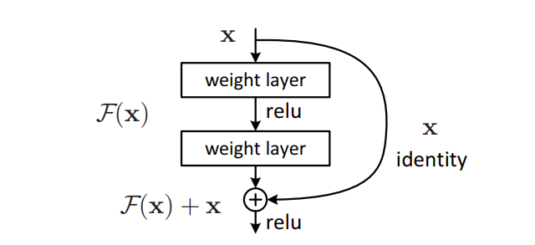

**Inception v3**

Inception v3 is an image recognition model that has been shown to attain greater than 78.1% accuracy on the ImageNet dataset. The model is the culmination of many ideas developed by multiple researchers over the years. It is based on the original paper: ["Rethinking the Inception Architecture for Computer Vision"](https://arxiv.org/abs/1512.00567) by Szegedy, et. al.

The model itself is made up of symmetric and asymmetric building blocks, including convolutions, average pooling, max pooling, concatenations, dropouts, and fully connected layers. Batch normalization is used extensively throughout the model and applied to activation inputs. Loss is computed using Softmax.

A high-level diagram of the model is shown in the following screenshot:

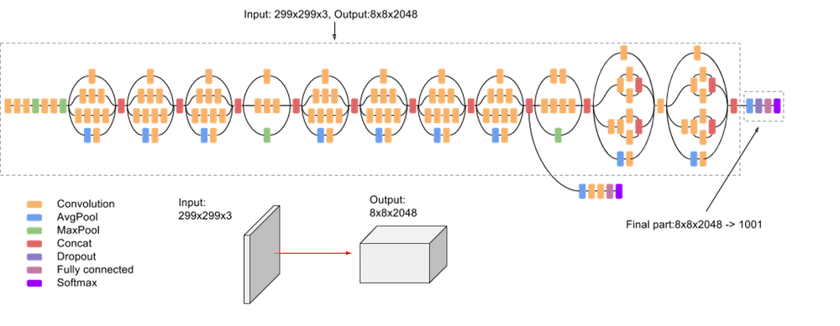

**Neural_network:**

Neural networks are inspired by the learning process that takes place in the human brain. They consist of an artificial network of functions called parameters that allow the computer to learn and adapt itself by analyzing new data. Each parameter, sometimes referred to as a neuron, is a function that produces an output after receiving one or more inputs. These outputs are then passed to the next layer of neurons, which use them as inputs to their own function and produce more outputs. These outputs are then passed to the next layer of neurons, and so on, until all layers of neurons have been considered and the terminal neurons have received their input. These terminal neurons then produce the final output for the model. Figure 1 shows a visual representation of such a network. The initial input is x, which is then passed to the first layer of neurons (the h-bubbles in Figure 1) where three functions take the input received and produce an output. This output is then passed to the second layer (the h-bubbles (bubbles in Figure 1) g in Figure 1). There more output is calculated based on the output of the first layer.This secondary output is then combined to create a final model output.

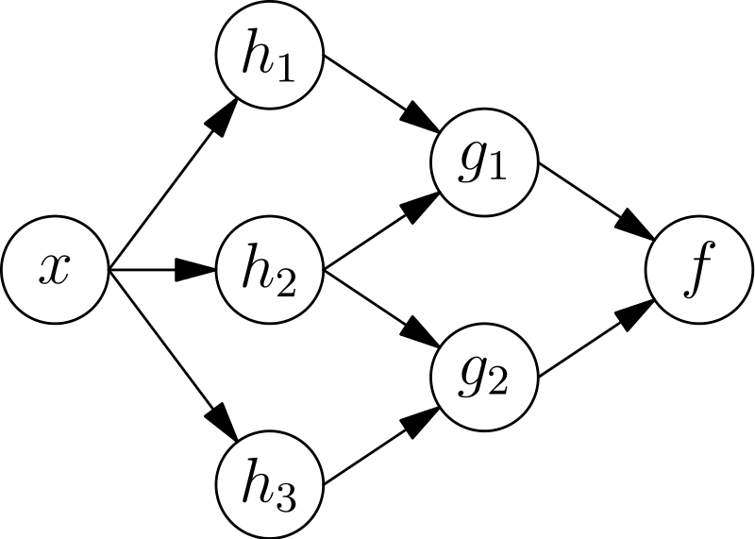

**Chapter 4**

**HARDWARE & SOFTWARE REQUIREMENT**

**Hardware Requirements**

* Linux: GNOME or KDE desktop GNU C Library (glibc) 2.15 or later, 2 GB RAM minimum,
* 4 GB RAM recommended, 1280 x 800 minimum screen resolution.
* Windows: Microsoft R Windows R 8/7/Vista (32 or 64-bit) 2 GB RAM minimum, 4 GB RAM
* recommended, 1280 x 800 minimum screen resolution, Intel R processor with support for Intel R
* VT-x, Intel R EM64T (Intel R 64) Execute Disable (XD) Bit functionality

**Software Specification:**

* Windows Operating System.
* MySQL
* Python
* Flask
* Anaconda ,Jupyter, Spyder

**Technologies Used:-**

1. **MySQL:**

Mysql is prestigious as worlds most by and large utilized ascii archive data back-end its most guarantee data for php as php-mysql is most habitually utilized ascii record prearranging data attempt the ui that wamp lamp and xampp workers offer for mysql is ideal and diminishes our work to an outsized degree

1. **Python:**

Python could likewise be a taken item organized basic level language with dynamic derivation its straightforward level in-created information structures got together with unique organization and dynamic restricting sort it outrageously interesting for speedy application advancement what’s more on be utilized as a pre piece or glue language to relate existing components on pythons clear direct to be told accentuation highlights quality by then decreases the cost of program fixes python maintains modules and packs that moves program quality and code utilize the python go-between and what’s more the escalated standard library are offered in give or combined sort to nothing of charge for each and every fundamental stage and wish to be uninhibitedly spread of programmers fall stricken with python because of the misrepresented strength it gives since there is no aggregation step the special stepped area test-investigate cycle is unfathomably expedient work python programs is basic a bug or unfortunate information won’t ever cause a division deformity taking everything into account once the interpreter discovers a blunder it raises an extraordinary case once the program doesn’t get the exception the go-between prints a stack follow a stock level program licenses assessment of local and world elements examination of self-emphatic enunciations setting breakpoints wandering through the code a line at a rapidly on the program is written in python itself vouching for pythons smart power barring generally the quick in view of right a program is to incorporate a few print clarifications to the accessibility the quick modify test-explore cycle makes this simple philosophy dreadfully amazing.

**4)Flask:**

A Flask is a Web Application Framework that is built with Flexibility and Speed In the Mind.Flask is Built in Python , which many data Scientists are familiar with . Flask takes care of the Environment and Project setup involved in web Applications Allowing the Developer to focus on their application rather than thinking about HTTP , routing , dataset etc. Flask allows Data Scientists to create simple Single page Applications and one should Help or look into if they want to create Products for Consumers Flask is a micro web framework written in Python. it is classified as a microframework because it doesn't require particular tools or libraries. There is no database abstraction layer, form validation, or the other components where pre-existing third-party libraries provide common functions. However, Flask supports extensions which will add application features as if they were implemented in Flask itself. Extensions exist for object-relational mappers, form validation, upload handling, various open authentication technologies and a number of other common framework related tools

Flask was created by Armin Ronacher of Pocoo, a world group of Python enthusiasts formed in 2004.According to Ronacher, the thought was originally an April Fools joke that was popular enough to form into significant application. When Ronacher and Georg Brandl created a bulletin board system written in Python, the Pocoo projects Werkzeug and Jinja were developed. Flask has become popular among Python enthusiasts. As of October 2020, its second most stars on GitHub among Python web-development frameworks, only slightly behind Django, and was voted the foremost popular web framework within the Python Developers Survey 2018.

These are some Important features of the Flask:

1. it is a Development Server

2. Debugger

3.RESTful request dispatching

4. Unicode Based

5. Flask have google app engine Compatibility

**Chapter 5**

**PLANNING AND ESTIMATION**

**Software development Life Cycle**

The entire project spanned for a duration of 6 months. In order to effectively design and develop a cost-effective model, the Waterfall model was practiced.

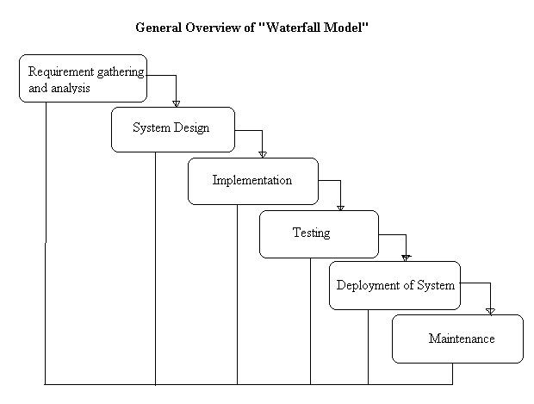

**Requirement gathering and Analysis phase:**

this phase started at the beginning of our project. We formed groups and modularized the project. Important points of consideration were

1. Define and visualize all the objectives clearly.

2.Gather requirements and evaluate them

Consider the technical requirements needed and then collect technical specifications of various peripheral components (Hardware) required.

3. Analyze the coding languages needed for the project.

4. Define coding strategies.

5. Analyze future risks / problems.

6. Define strategies to avoid these risks and define alternate solutions to these risks.

7. Check financial feasibility.

8. Define Gantt charts and assign a time span for each phase.

By studying the project extensively we developed a Gantt chart to track and schedule the project. Below is the Gantt chart of our project.

**TimeLineChart**

**Please make changes as per your requirement**

| Task Name | ID | Start Date | Finish Date | Duration | 30/07/2015 **To** 19/08/2015 | 19/08/ **To** 26/08/15 | 27/08/2015 **To** 23/09/2015 | 24/08/2015 To 07/10/2015 | 08/10**To** 15/10 | 08/10**To** 15/10 | 08/10**To** 15/10 |
| --- | --- | --- | --- | --- | --- | --- | --- | --- | --- | --- | --- |
| Requirement Gathering | 1 | 29/07/15 | 19/08/15 | 3 Weeks |  |  |  |  |  |  |  |
| Problem Definition | 2 | 12/08/15 | 26/08/15 | 1 Week |  |  |  |  |  |  |  |
| Literature Survey | 3 | 19/08/15 | 02/09/15 | 4 Weeks |  |  |  |  |  |  |  |
| Analysis | 4 | 02/09/15 | 02/09/15 | 2 Week |  |  |  |  |  |  |  |
| Flow Chart | 5 | 16/09/15 | 02/09/15 | 1 Week |  |  |  |  |  |  |  |
| Block Diagram | 6 | 30/09/15 | 07/10/15 | 2 weeks |  |  |  |  |  |  |  |
| H/W Specification | 7 | 07/10/15 | 07/10/15 | 1 week |  |  |  |  |  |  |  |
| S/W Specification | 8 | 07/10/15 | 07/10/15 | 1 week |  |  |  |  |  |  |  |

**Cost Estimation**

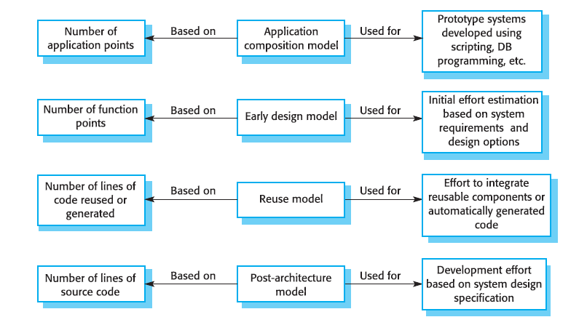

Cost estimation is done using cocomo model

| cost Drivers | **Ratings** | | | | | |
| --- | --- | --- | --- | --- | --- | --- |
| Very Low | Low | Nominal | High | Very High | Extra High |
| **Product attributes** |  |  |  |  |  |  |
| Required software reliability | 0.75 | 0.88 | 1.00 | 1.15 | 1.40 |  |
| Size of application database |  | 0.94 | 1.00 | 1.08 | 1.16 |  |
| Complexity of the product | 0.70 | 0.85 | 1.00 | 1.15 | 1.30 | 1.65 |
| **Hardware attributes** |  |  |  |  |  |  |
| Run-time performance constraints |  |  | 1.00 | 1.11 | 1.30 | 1.66 |
| Memory constraints |  |  | 1.00 | 1.06 | 1.21 | 1.56 |
| Volatility of the virtual machine environment |  | 0.87 | 1.00 | 1.15 | 1.30 |  |
| Required turnabout time |  | 0.87 | 1.00 | 1.07 | 1.15 |  |
| **Personnel attributes** |  |  |  |  |  |  |
| Analyst capability | 1.46 | 1.19 | 1.00 | 0.86 | 0.71 |  |
| Applications experience | 1.29 | 1.13 | 1.00 | 0.91 | 0.82 |  |
| Software engineer capability | 1.42 | 1.17 | 1.00 | 0.86 | 0.70 |  |
| Virtual machine experience | 1.21 | 1.10 | 1.00 | 0.90 |  |  |
| Programming language experience | 1.14 | 1.07 | 1.00 | 0.95 |  |  |
| **Project attributes** |  |  |  |  |  |  |
| Use of software tools | 1.24 | 1.10 | 1.00 | 0.91 | 0.82 |  |
| Application of software engineering methods | 1.24 | 1.10 | 1.00 | 0.91 | 0.83 |  |
| Required development schedule | 1.23 | 1.08 | 1.00 | 1.04 | 1.10 |  |

The Intermediate Cocomo formula now takes the form:

**E=*ai*(KLoC)*(bi)*.EAF**

Using above calculation we found that the total time period of the project is around 6 months, the per month cost comes out to be Rs.12, 000/- so the total comes to be Rs.72, 000/-

**FEASIBILITY STUDY**

This system is possible for all health care departments like science lab hospital and clinic etc and this method can use while not specialists in this field anyone can use who have data concerning using online services which is able to facilitate to use this method any generation folks can use this method in laptop

**TECHNICAL FEASIBILITY**

The framework ought to be assessed from the specialized reason for read first the evaluation of this practicability ought to be upheld a rundown kind of the framework interest inside the provisions of info yield projects and techniques having known an outline framework the examination ought to keep up to suggest the kind of pack required approach building up the framework of running the framework whenever it has been planned. 21 1. Is the existing technology sufficient for the suggested one? 2. Can the system expand if developed? the undertaking should be created indicated the predetermined capacities and execution are accomplished among the limitations the task is created among most recent innovation through the innovation may become old once some measure of some time due to the specific undeniable truth that never form of same code upholds more seasoned variants the framework should in any case be utilized hence there are marginal imperatives included this task the framework has been created exploitation python the undertaking is in fact feasible for advancement

**ECONOMIC FEASIBILITY**

The creating framework ought to be even by worth and benefit. Measures to confirm that exertion is focused on a project, which may give best, come at the most punctual. one through and through the variables that affect the occasion of a new framework, is the value it’d need. The following are an assortment of the necessary cash questions asked all through the starter examination:

1. They conduct a full system investigation.
2. The cost of the hardware and software.
3. The benefits in the form of reduced costs or fewer costly errors.

Since the framework is created as a neighborhood of task work, there is no manual worth to purchase the projected framework. Furthermore every one of the assets are as of now available, it offers an image of the framework is financially feasible for improvement.

**BEHAVIORAL FEASIBILITY**

This incorporates the following inquiries:

1. Is there agreeable help for the clients?
2. Will the arranged framework hurt?

The venture would be useful as an aftereffect of fulfilling the goals once created and introduced. All social perspectives are considered cautiously and presume that the undertaking is typically conceivable

**RISK ANALYSIS PROCESS**

Notwithstanding the obstacle strategies utilized potential perils is in a position to which can arise inside or outside the affiliation ought to be assessed regardless of the established truth that the exact arrangement of expected catastrophes or their after results district unit delayed to outlined its valuable to play out an intensive risk investigation of all threats which can sensibly happen to the relationship in spite of the kind of peril the goals of business recuperating emerging with locale unit to validate the security of buyers workers and particular representatives eventually of and following a breakdown the overall probability of a failure happening should be settled things to appear at in urgent the probability of a particular breakdown should be constrained to represent in any case not be confined to field characteristic study of the planet closeness to indispensable wellsprings of power streams and air terminals level of receptiveness to workplaces inside the affiliation history of local service organizations in giving persistent kinds of help history of the spaces condition to standard risks neighborhood to imperative turnpikes that vehicle bold waste and combustible item. Potential openings could even be delegated regular, specialized, or human dangers. Models include:

**Characteristic Threats:** inner flooding, outer flooding, interior hearth, outside chimney, seismic movement, high breezes, snow and ice storms, emission, cyclone, typhoon, pandemic, torrent , hurricane.

**Specialized Threats:** power disappointment/variance, warming, ventilation or air con disappointment, glitch or disappointment of hardware , disappointment of framework code, disappointment of use code, broadcast communications disappointment, gas spills, interchanges disappointment, atomic aftermath.

**Human** **Threats**:robbery, bomb dangers, theft, blackmail, thievery, defacing, psychological warfare, common problem, synthetic spill, damage, blast, war, natural pollution, radiation tainting, perilous waste, vehicle crash, airdrome nearness, strike (Internal/External), PC wrongdoing. All areas and offices should be encased inside the peril investigation maybe than attempting to sort out real prospects of every fiasco an overall relative game plan of high medium and low is utilized at first to distinguish the probability of the danger happening the possibility investigation also need to affirm the effect of such a likely danger on various capacities or offices inside the association a risk analysis type discovered here pdf format will work with the strategy the capacities or divisions can shift by kind of association the arranging strategy ought to set up and live the possibility of every single expected danger and in this way the effect on the association if that danger happened to attempt to this each division should be investigated severally in spite of the fact that the chief framework is furthermore the one most serious danger it isn’t the solitary vital concern indeed even inside the first programmed associations a few offices will not be handled or programmed inside the smallest degree in totally programmed divisions essential records stay outside the framework as lawful records pc information programming bundle hang on diskettes or supporting documentation for data section the effect is evaluated as 0 no effect or break in tasks 1 noticeable effect break in activities for as long as eight hours 2 mischief to instrumentation and additionally offices break in tasks for eight 48 hours 3 major damage to the instrumentation or potentially offices break in tasks for very 48 hours all base camp or potentially pc focus capacities ought to be resettled bound suspicions is also important to consistently apply evaluations to every possible danger

**Functional requirements :**

1. System should have sufficient internet to fetch the data from the server.
2. The system will acquire all data on a daily basis.
3. System should be able to match required configurations.
4. Database should be updated with the latest values.
5. The system should have to display

**Non-functional requirements :**

1. The reliability of the product will be dependent on the accuracy of the data.
2. Web site will display normal data on Tweets such as Positive, Negative, Neutral
3. Website will display the graph as an overlay on the positive, negative, neutral count.
4. Site is hands on or friendly so that customers can view / use it easily.
5. The processing speed of the prediction algorithm should be less than a minute.

**Chapter 6**

**TESTING**

**Testing:**

Deep learning has emerged as a powerful tool in the field of medical research, particularly in the study of brain pathology. Leveraging advanced neural networks, deep learning models can analyze complex patterns and relationships within medical imaging data, enabling more accurate and efficient diagnosis of various brain disorders. These models excel in tasks such as tumor detection, classification of lesions, and segmentation of brain structures. In the realm of testing, these deep learning algorithms undergo rigorous evaluation to ensure their reliability and generalizability across diverse datasets. Researchers employ validation techniques, cross-validation, and independent testing on new datasets to assess the model's performance and robustness. This thorough testing process aims to validate the effectiveness of deep learning in brain pathology analysis, paving the way for enhanced diagnostic capabilities and improved patient outcomes.

**Error and exception handling:**

Above all else, you need in the first place information troubleshooting as a consequence of the precision of expectations made by the model depends not just on the calculation anyway on the nature of information itself.

**Data set pattern:**

One apparatus that assists you with seeing whether the information contains the normal factual qualities is the data blueprint. A data set outline is somewhat of a guide that portrays the rationale of the information base: anyway the data is coordinated and what the connection between the examples is. it's having the chance to incorporate certain guidelines like Guarantee that the submitted values are in the 1-5 territory (in evaluations, for instance .

**Pre-train tests:**

This sort of take a look at is performed early and licenses you to get bugs prior to running the model. they're not truly like instructing boundaries to be run. a partner illustration of a pre-train take a look at may be a program that checks whether there are any marks missing in your preparation and approval datasets.

**Post-train tests :**

These tests are performed on a prepared model and check whether it performs appropriately. They permit us to explore the rationale behind the calculation and see whether there are any bugs there. There are 3 kinds of tests that report the conduct of the program:

Invariance tests. exploitation of constant tests, we'll check to what extent we'll adjust the info while not contacting the presentation of the model. we'll consolidate input models and check for consistency in forecasts. For instance , on the off chance that we will in general run an example acknowledgment model on 2 totally extraordinary photographs of red apples, we will in general expect that the outcome will not change bountifully.

**FeatureExtraction:**  
Deep learning has emerged as a powerful tool in the field of brain pathology, particularly in the realm of feature extraction. Feature extraction plays a pivotal role in understanding and characterizing intricate patterns within medical imaging data, such as MRI or CT scans. By leveraging deep learning algorithms, researchers can automatically identify relevant features from these images, facilitating the detection and diagnosis of various brain pathologies, including tumors, lesions, and neurodegenerative disorders.

The process of feature extraction involves the automatic identification and extraction of distinctive patterns or features from raw imaging data. Deep learning models, such as convolutional neural networks (CNNs), excel in this task by learning hierarchical representations of data. These networks can discern complex structures and subtle abnormalities within brain images that might elude traditional image processing techniques.

One key advantage of using deep learning for feature extraction in brain pathology is its ability to handle large and diverse datasets. As these models learn from extensive data, they become adept at recognizing both common and rare patterns associated with different pathologies. This adaptability enhances diagnostic accuracy and enables the identification of subtle anomalies that might be challenging for human observers to detect.

Moreover, the continual advancements in deep learning architectures, coupled with the availability of extensive labeled datasets, contribute to the ongoing refinement of feature extraction methods. This iterative process enhances the reliability and generalizability of deep learning models for brain pathology analysis.

In conclusion, the application of deep learning for feature extraction in brain pathology not only automates and accelerates the diagnostic process but also holds promise for uncovering new insights into the complexities of neurological disorders. As researchers continue to refine and expand the capabilities of these models, they pave the way for more accurate and efficient tools in the diagnosis and understanding of brain pathologies.

**Chapter 7**

**Design & Implementation**

**SYSTEM IMPLEMENTATION**

**ER -DIAGRAM:**

The ER or (Entity Relational Model) is a high-level conceptual data model diagram. Entity-Relation model is based on the notion of real-world entities and the relationship between them.

An Entity Relationship (ER) Diagram is a type of flowchart that illustrates how “entities” such as people, objects or concepts relate to each other within a system.

ER diagrams are related to data structure diagrams (DSDs), which focus on the relationships of elements within entities instead of relationships between entities themselves. ER modeling is something regarded as a complete approach to design a logical database schema. This is incorrect because the ER diagram is just an approximate description of data, constructed through a very subjective evaluation of the information collected during requirements analysis.

ER Diagrams are composed of entities, relationships and attributes. They also depict cardinality, which defines relationships in terms of numbers.

* **Entity**

An entity is an object or component of data. An entity is represented as a rectangle in an ER diagram.  
For example: Student and College and these two entities have many to one relationship as many student studies in a single college.

An entity that cannot be uniquely identified by its own attributes and relies on the relationship with another entity is called a weak **entity**. The weak entity is represented by a double rectangle.

* **Attribute**

An attribute describes the property of an entity. An attribute is represented as Oval in an ER diagram. There are four types of attributes:

1. Key attribute  
2. Composite attribute  
3. Multivalued attribute  
4. Derived attribute

* **Relationship**

A relationship is represented by diamond shape in the ER diagram, it shows the relationship among entities. There are four types of relationships:  
 1. One to One  
 2. One to Many  
 3. Many to One  
 4. Many to Many

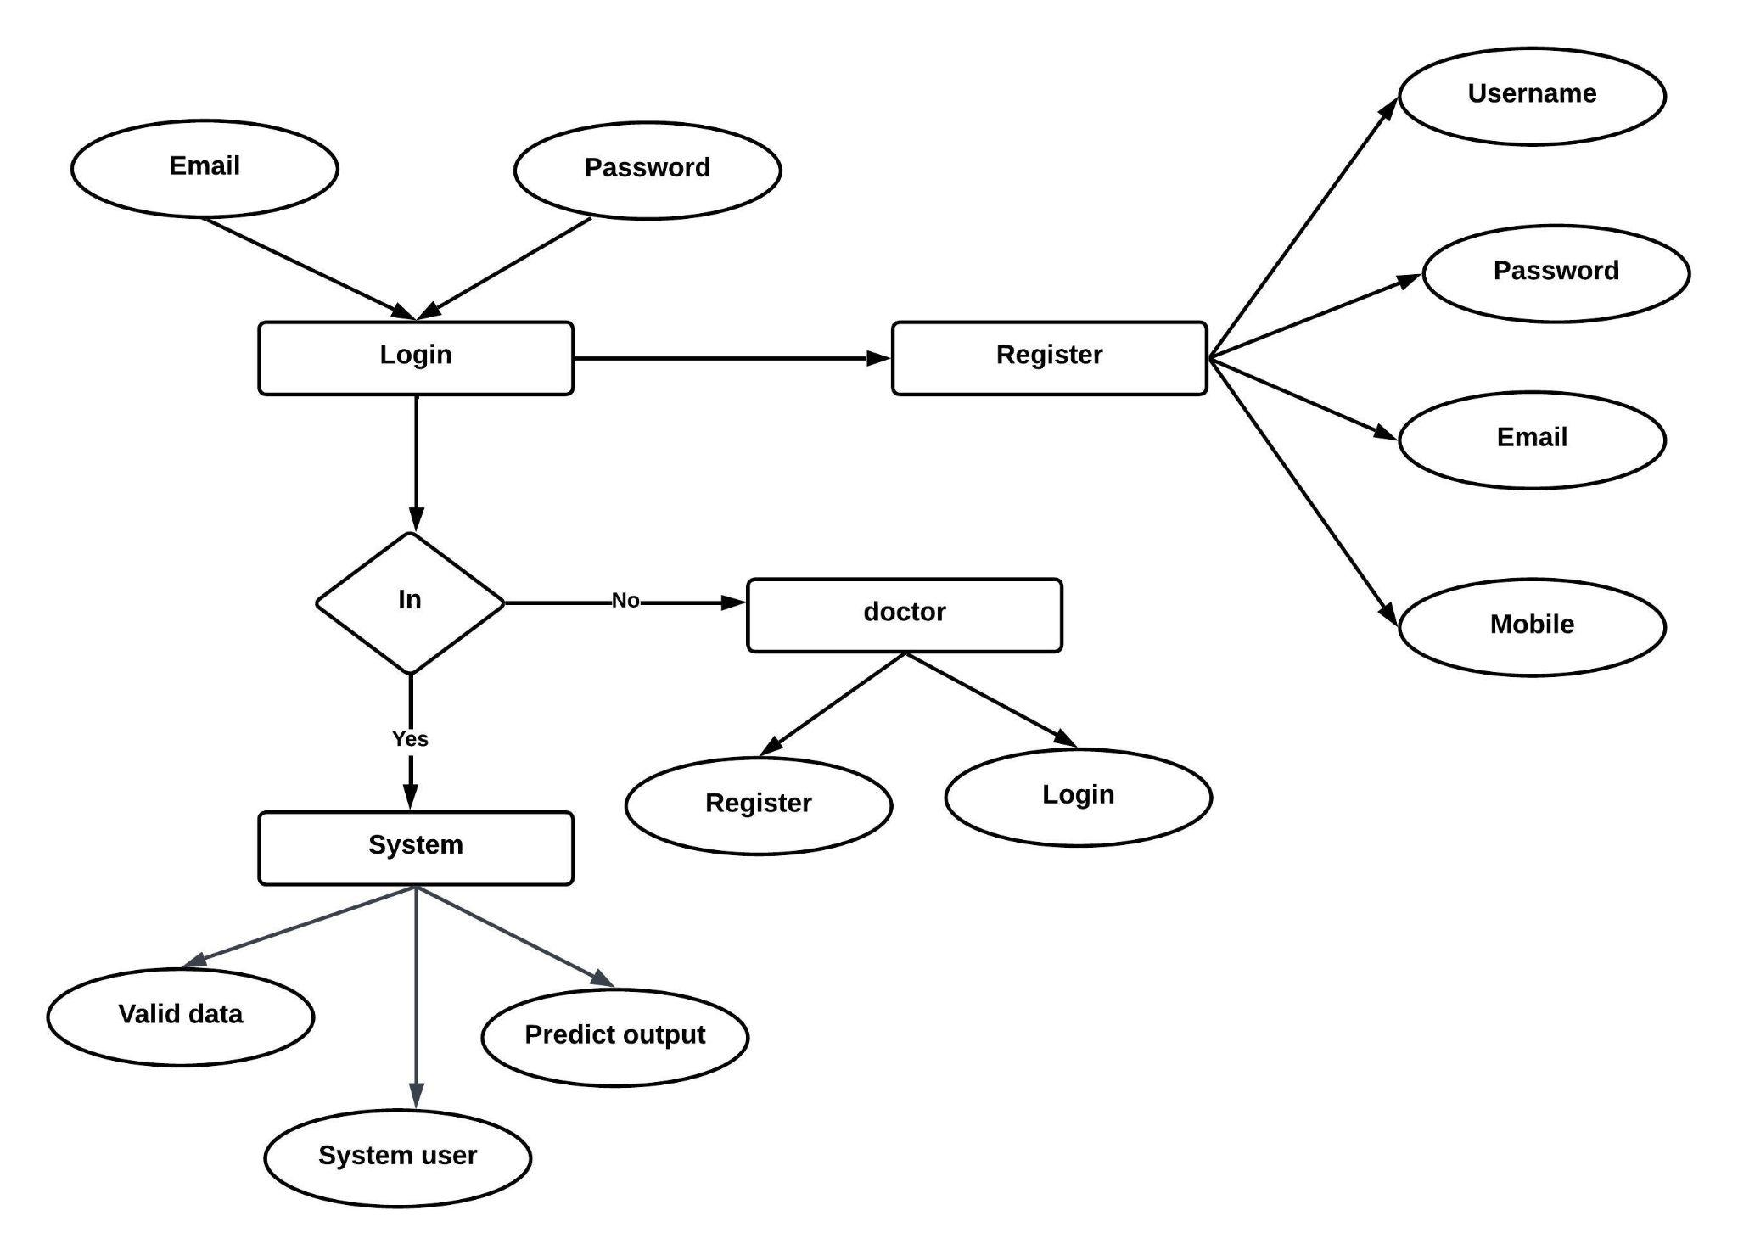

**FLOWCHART:**

Flow diagrams are graphical representations of workflows of stepwise activities and actions with support for choice, iteration and concurrency. In the Unified Modeling Language, Flow diagrams can be used to describe the business and operational step-by- step workflows of components in a system. An activity diagram shows the overall flow of control. A Flow diagram shows the overall flow of control. Flow diagrams are constructed from a limited repertoire of shapes, connected with arrows.

Flow diagrams are constructed from a limited repertoire of shapes, connected with arrows.

The most important shape types:

● The rectangle represents Flow .

● Diamonds represent decisions.

● Bars represent the start (split) or end (join) of concurrent activities.

● A rectangle represents the start (initial state) of the workflow.

● An end rectangle represents the end (final state).

● Arrows run from the start towards the end and represent the order in which activities happen.

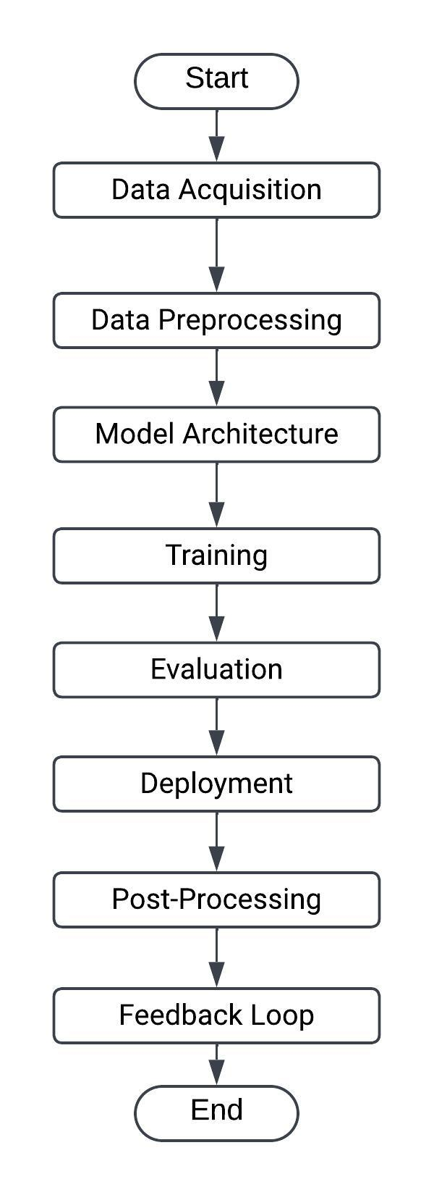

**Context level Data Flow Diagram:**

Data Flow Diagram (DFD) is a graphical representation of data flow in any system. It is capable of illustrating incoming data flow, outgoing data flow and store data. There is a major difference between data flow diagrams and flowchart.. Data flow diagrams illustrate flow of data in the system at various levels. Data flow diagram does not have any control or branch elements.Data flow diagram describes anything about how data flows through the system.Sometimes people get confused between data flow diagram and flowchart. The flowchart illustrates flow control in program modules

**Components of Data Flow Diagram**:

**Entities:**

Entities include source and destination of the data. Entities are represented by a rectangle with their corresponding names.

**Process:**

The tasks performed on the data are known as processes. Process is represented by a circle. Somewhere round edge rectangles are also used to represent the process.

**Data Storage:**

Data storage includes the database of the system. It is represented by a rectangle with both smaller sides missing or in other words within two parallel lines.

**Data Flow:**

The movement of data in the system is known as data flow. It is represented with the help of an arrow. The tail of the arrow is the source and the head of the arrow is the destination.

DFD Level 0:-















Activity diagram:

Activity diagrams are graphical representations of workflows of stepwise activities and actions with support for choice, iteration and concurrency. In the Unified Modeling Language, activity diagrams can be used to describe the business and operational step-by- step workflows of components in a system. An activity diagram shows the overall flow of control. An activity diagram shows the overall flow of control. Activity diagrams are constructed from a limited repertoire of shapes, connected with arrows.

Activity diagrams are constructed from a limited repertoire of shapes, connected with arrows.

The most important shape types:

● Rounded rectangle represents activities.

● Diamonds represent decisions.

● Bars represent the start (split) or end (join) of concurrent activities.

● A black circle represents the start (initial state) of the workflow.

● An encircled black circle represents the end (final state).

● Arrows run from the start towards the end and represent the order in which activities happen.

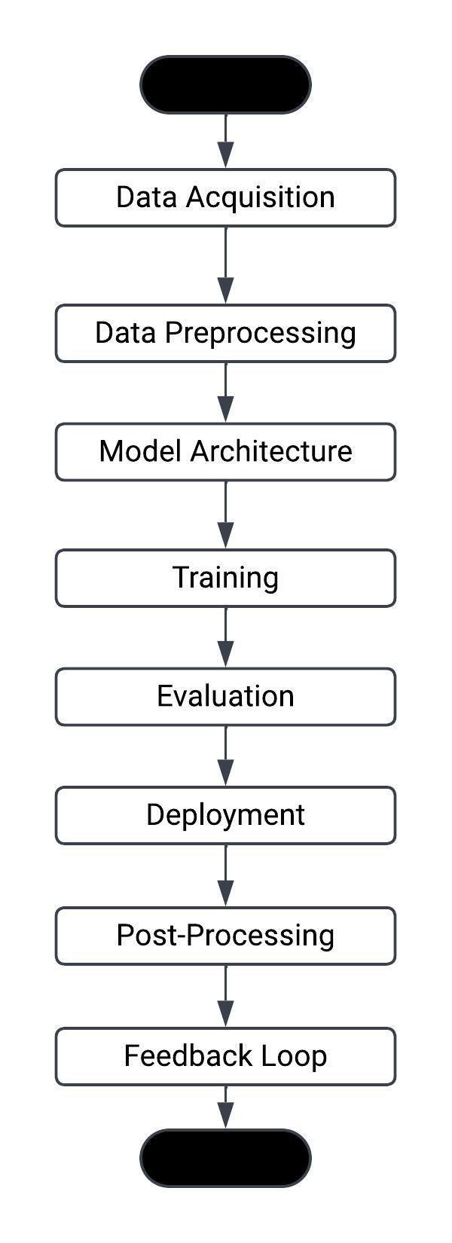

Class diagram:

It is a model which is used to show the classes constituting a system and their interrelationship. It is based on UML. Only the important attributes and methods are shown in Class diagrams. In the initial period of analysis, the important attributes of the classes, which must be captured and the functionalities provided by the class may not be very clear. As the analysis progresses, the attributes and methods may be added. If more focus is on interrelationships of classes, then the attributes and methods may not be shown in the class diagram.

The class diagram is used to identify and classify the objects which constitute a system. It also includes the important attributes of the objects which must be captured.

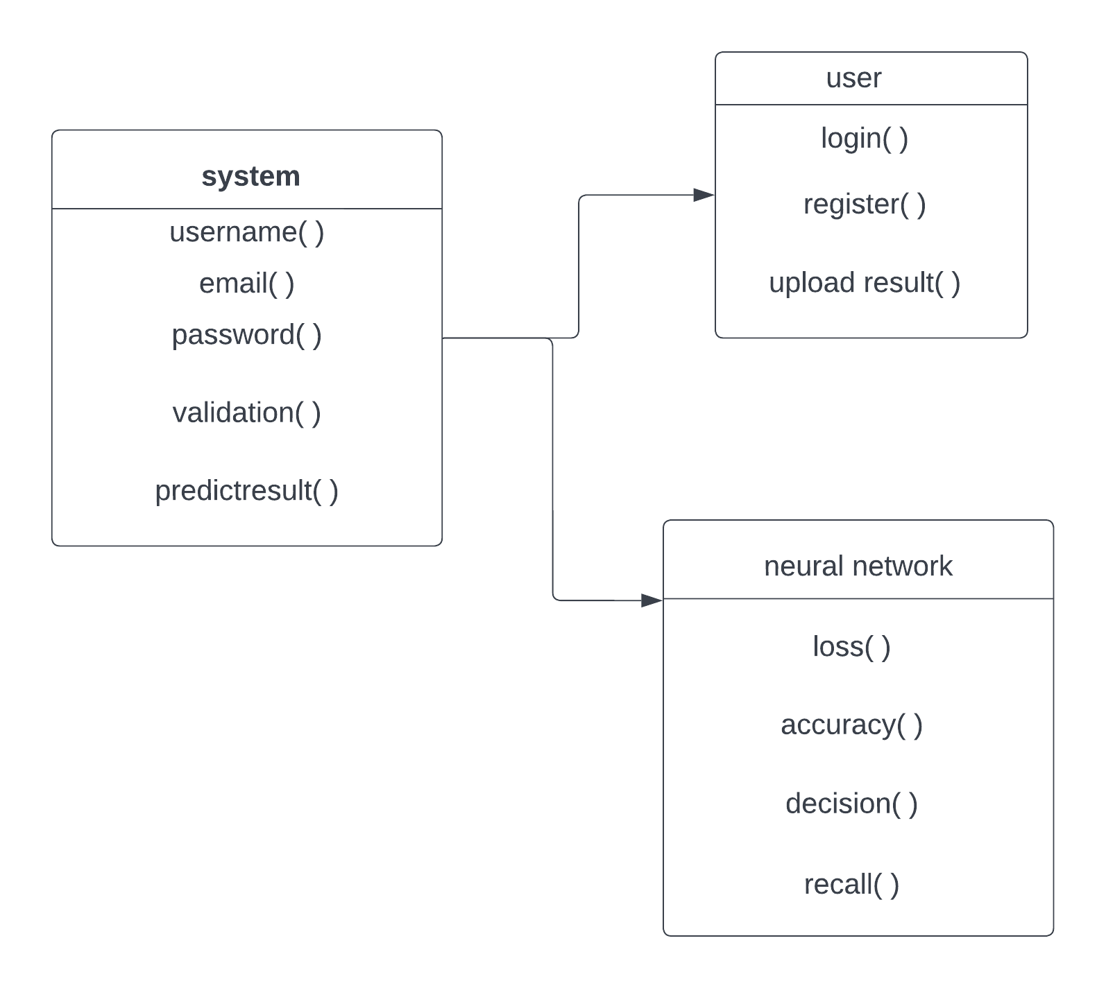

**Use Case Diagram:**

A use case diagram is a dynamic or behavior diagram within the Unified Modelling Language (UML) framework. Its purpose is to model the operational functionality of a system by illustrating the interactions between actors and use cases. Use cases encompass a series of actions, services, and functions that the system must execute. Here, the term "system" refers to the entity being developed or operated, such as a website, while "actors" represent individuals or entities assuming defined roles within the system's operation. These diagrams play a crucial role in visually representing the functional requisites of a system, thereby guiding design decisions and development priorities. Additionally, they serve to pinpoint both internal and external factors that may exert influence on the system, necessitating careful consideration. By focusing on how the system engages with actors, use case diagrams spare the intricacies of implementation, offering a valuable, high-level analysis from an external perspective.

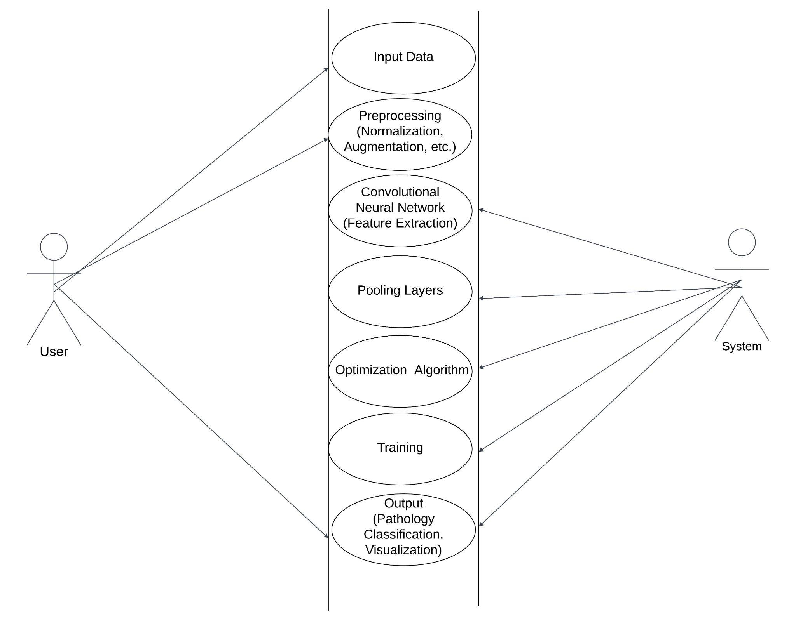

**Chapter 8**

**ADVANTAGES**

Deep learning has emerged as a transformative tool in the field of brain pathology, offering a plethora of advantages in the diagnosis and understanding of neurological disorders. One of the key advantages is its ability to process vast amounts of complex data with remarkable speed and efficiency. Deep learning algorithms excel at extracting intricate patterns and features from medical imaging, such as magnetic resonance imaging (MRI) and computed tomography (CT) scans, enabling more accurate and timely detection of abnormalities.

Moreover, deep learning models can adapt and learn from diverse datasets, allowing for enhanced generalization across different patient populations and pathological variations. This adaptability contributes to improved diagnostic accuracy and the potential for early detection of neurological conditions. The integration of deep learning in brain pathology also facilitates personalized medicine by tailoring treatment plans based on individual patient characteristics, leading to more effective and targeted interventions.

Another advantage lies in the automation of repetitive and time-consuming tasks, freeing up healthcare professionals to focus on more intricate aspects of patient care. Deep learning algorithms can assist in the segmentation of brain structures, identification of anomalies, and even prediction of disease progression. This not only accelerates the diagnostic process but also contributes to a more streamlined and resource-efficient healthcare system.

Additionally, ongoing advancements in deep learning techniques, such as convolutional neural networks and recurrent neural networks, continually enhance the field's capabilities. This adaptability ensures that as new data becomes available and technology evolves, deep learning models can be refined and optimized, further improving their diagnostic accuracy and reliability. In summary, the integration of deep learning in brain pathology offers a promising avenue for more efficient, accurate, and personalized diagnosis and treatment of neurological disorders.

**Chapter 10**

**Results and Discussion**

**& CONCLUSION**

**Results and Discussion:**

Deep learning has emerged as a powerful tool in the field of medical research, particularly in the study of brain pathology. The application of deep learning techniques to analyze neuroimaging data has yielded promising results, revolutionizing our understanding and diagnostic capabilities for various neurological disorders. One notable achievement is the improved accuracy and efficiency in the detection and classification of brain abnormalities, such as tumors, lesions, and neurodegenerative diseases.

The integration of convolutional neural networks (CNNs) and recurrent neural networks (RNNs) has enabled the development of sophisticated models capable of learning intricate patterns and subtle nuances in brain images. This has significantly enhanced the ability to differentiate between normal and pathological conditions, facilitating earlier and more accurate diagnoses. Deep learning algorithms have also demonstrated a remarkable capacity for feature extraction, enabling the identification of subtle changes in brain structures that might be imperceptible to the human eye.

Moreover, the utilization of large datasets for training deep learning models has contributed to their robustness and generalizability. By exposing these algorithms to diverse and extensive datasets, they can learn from a wide range of cases, ensuring adaptability to various clinical scenarios. This adaptability is crucial in handling the inherent heterogeneity in brain pathology, where different individuals may present with unique patterns of abnormalities.

Despite these advancements, challenges and considerations persist in the application of deep learning to brain pathology. Interpretability of the models remains a key concern, as understanding the rationale behind a model's decision is crucial for gaining clinicians' trust. Additionally, issues related to data privacy, ethical considerations, and the need for standardized datasets pose ongoing challenges in the field.

In conclusion, the integration of deep learning into the study of brain pathology has demonstrated significant strides in improving diagnostic accuracy and efficiency. These advancements hold immense potential for revolutionizing clinical practice, offering new avenues for early detection and personalized treatment strategies. Continued research, addressing the aforementioned challenges, will further refine and optimize deep learning models for their integration into routine clinical workflows, ultimately benefiting patients and enhancing our understanding of brain disorders.

**Feature**

Deep learning has emerged as a powerful tool in the field of medical imaging, particularly for the detection and diagnosis of brain pathology. Leveraging complex neural networks, deep learning models can analyze intricate patterns and features within medical images, enabling more accurate and efficient identification of abnormalities in the brain. One key feature of deep learning in this context is its ability to automatically extract relevant features from imaging data, eliminating the need for manual and time-consuming analysis. These features may include subtle changes in tissue texture, shape irregularities, or specific lesion characteristics that are indicative of various brain pathologies such as tumors, aneurysms, or neurodegenerative disorders. By training on large datasets, deep learning models can generalize their learning to new cases, improving diagnostic accuracy and potentially aiding healthcare professionals in making timely and informed decisions. However, the deployment of such technologies necessitates careful validation, ethical considerations, and ongoing collaboration between technologists and medical experts to ensure reliable and safe integration into clinical practice.

**CONCLUSION:**

In conclusion, the integration of deep learning techniques in the field of brain pathology has demonstrated significant promise and potential for advancing our understanding of complex neurological disorders. The application of deep learning algorithms to medical imaging, particularly in the analysis of brain scans, has facilitated more accurate and timely diagnosis, allowing for early intervention and improved patient outcomes. By leveraging the power of artificial intelligence, researchers and clinicians have been able to identify subtle patterns and abnormalities in brain images that might otherwise go unnoticed. This transformative approach not only enhances diagnostic precision but also opens avenues for personalized treatment strategies tailored to individual patient needs. While the field is still evolving, and challenges such as data privacy and interpretability need careful consideration, the positive strides made thus far underscore the profound impact deep learning can have on unraveling the intricacies of brain pathology. As technology continues to advance, the synergy between deep learning and neurology holds great promise for revolutionizing our approach to the diagnosis and management of various neurological conditions.

**Chapter 11**

**BIBLIOGRAPHY**

**Bibliography:**

1. Isles challenge 2015: Ischemic stroke lesion segmentation. http://www. isles-challenge.org/ISLES2015/. Accessed 11 June 2016

2. Virtual skeleton database. http://www.virtualskeleton.ch/. Accessed 11 June 2016

3. Ali, H., Elmogy, M., El-Daydamony, E., Atwan, A.: Multi-resolution mri brain image segmentation based on morphological pyramid and fuzzy c-mean clustering. Arab. J. Sci. Eng. 40(11), 3173–3185 (2015)

4. Alvarez, J.M., Gevers, T., LeCun, Y., Lopez, A.M.: Road scene segmentation from a single image. In: Fitzgibbon, A., Lazebnik, S., Perona, P., Sato, Y., Schmid, C. (eds.) ECCV 2012. LNCS, vol. 7578, pp. 376–389. Springer, Heidelberg (2012). doi:10.1007/978-3-642-33786-4 28

5. Arevalo, J., Gonzalez, F.A., Ramos-Pollan, R., Oliveira, J.L., Guevara Lopez, M.A.: Convolutional neural networks for mammography mass lesion classification. In: 37th Annual International Conference of the IEEE Engineering in Medicine and Biology Society (EMBC), pp. 797–800. IEEE (2015)

6. Bakas, S., Zeng, K., Sotiras, A., Rathore, S., Akbari, H., Gaonkar, B., Rozycki, M., Pati, S., Davazikos, C.: Segmentation of gliomas in multimodal magnetic resonance imaging volumes based on a hybrid generative-discriminative framework. In: Proceeding of the Multimodal Brain Tumor Image Segmentation Challenge, pp. 5–12 (2015)

7. Bar, Y., Diamant, I., Wolf, L., Greenspan, H.: Deep learning with non-medical training used for chest pathology identification. In: SPIE Medical Imaging, p. 94140V. International Society for Optics and Photonics (2015)

8. Bauer, S., et al.: A survey of MRI-based medical image analysis for brain tumor studies. Phy. Med. Biol. 58(13), 97–129 (2013)

9. Bauer, S., Wiest, R., Reyes, M.: segmentation of brain tumor images based on integrated hierarchical classification and regularization. In: proceeding of BRATS MICCAI (2012)

10. Bengio, Y., Courville, A., Vincent, P.: Representation learning: a review and new perspectives. IEEE Trans. Pattern Anal. Mach. Intell. 35(8), 1798–1828 (2013)

11. Brosch, T., Tang, L., Yoo, Y., Li, D., Traboulsee, A., Tam, R.: Deep 3D convolutional encoder networks with shortcuts for multiscale feature integration applied to multiple sclerosis lesion segmentation. IEEE Trans. Med. Imaging (2016)

12. Brosch, T., Yoo, Y., Tang, L.Y.W., Li, D.K.B., Traboulsee, A., Tam, R.: Deep convolutional encoder networks for multiple sclerosis lesion segmentation. In: Navab, N., Hornegger, J., Wells, W.M., Frangi, A.F. (eds.) MICCAI 2015. LNCS, vol. 9351, pp. 3–11. Springer, Heidelberg (2015). doi:10.1007/978-3-319-24574-4 1

**Chapter 11**

**SCREENSHOTS**

**Chapter 12**

**SOURCE CODE**